Tokyo City Tours at COMPSAC 2018
The service will be provided for all foreign delegates to welcome them to Tokyo.
Sponsor: Tokyo Metropolitan Government
Operator: Tokyo Convention & Visitors Bureau

Complimentary bus tours with an English-speaking guide to help participants enjoy the most popular sightseeing areas in Tokyo. All tours depart from and arrive at the Meeting Venue. Reservation can only be made at the “Tokyo City Information” Desk on a first-come, first-served basis. Only overseas participants and persons accompanying them can join this tour. The following is the itinerary for our city tours.

Itinerary
Date | Time / Contents
July 23rd | On-site booking is available at the Tokyo City Information Desk | PM (13:30-17:00)
 |  | TOKYO SKYTREE® (40 ppl）
 |  | River Cruise & Hama-rikyu Japanese Gardens (40ppl）
July 27th | AM (9:00-12:30) | PM (13:30-17:00)
 | Meiji Jingu Shrine & Harajuku Shopping (40 ppl) | TOKYO SKYTREE® (40 ppl）
 | Edo-Tokyo Museum and Asakusa (40 ppl) | River Cruise & Hama-rikyu  Japanese Gardens (40ppl）

Half day trip
T-1 TOKYO SKYTREE® – A view to top the rest
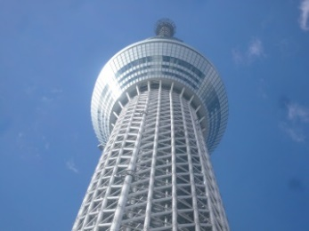
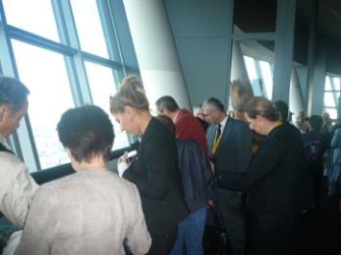
The capital city’s latest icon, and the world tallest broadcasting tower 634m high, is located in Sumida ward, where Edo culture thrives to this day. The elevator moving at a top speed of 600m per minute will take participants to the glass-enclosed 360° observation deck at 350m above ground. The main structure consists of a steel skeleton reinforced by steel frames to double the standard strength.
Many of the famous features of the Tokyo cityscape, including Rainbow Bridge in the bay area, and, on a clear day, Mt. Fuji in the distance, can be enjoyed from the observation deck.

T-2 River Cruise and Hama-rikyu Gardens
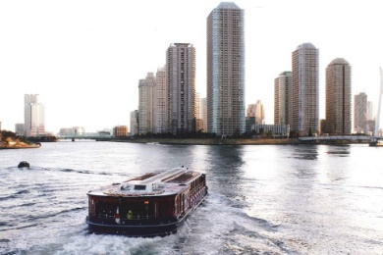
Half-hour boat cruise down the Sumida River travels under some 14 bridges spanning Tokyo’s main river, passing the capital’s famous landmarks along the way. The cruise arrives at its destination, the majestic Hama-rikyu Gardens along the Tokyo Waterfront in Shiodome, where the participants can walk around a beautifully preserved garden that the family of the ruling Tokugawa Shogun owned from the 17th to the mid-19th century and used for hunting with falcons.

T-3 Meiji Jingu Shrine & Harajuku Shopping
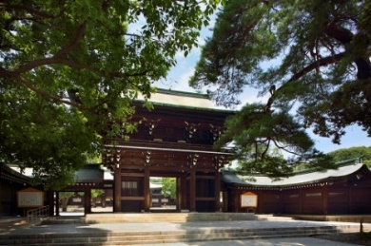
The Meiji Jingu Shrine is a Shinto shrine, dedicated to Emperor Meiji and his wife Empress Shoken, was established in 1920. Over 100,000 trees were donated by people all over Japan at the time of the shrine's establishment, creating the expanse of forest and garden that can be seen today. On the first few days of every New Year more than three million people visit Meiji Jingu, making it the most-visited shrine in Japan. Meiji Jingu Shrine is also the place where Japanese people honor life events, such as births, weddings and New Year’s celebrations.

T-4 Edo-Tokyo Museum and Asakusa
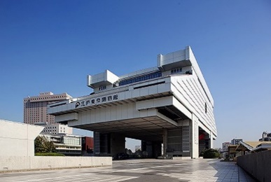
Edo-Tokyo Museum introduces the history and culture of Edo (the ancient name for Tokyo). It also fascinates visitors with stories of the city's captivating past. You can take a look at a traditional playhouse (theatre), and scenes from everyday life that will transport you back in time to the Edo-period (1603-1868). This museum presents visitors with a unique opportunity to compare and contrast old Edo with modern Tokyo, so you can appreciate how Tokyo has transformed over the years.

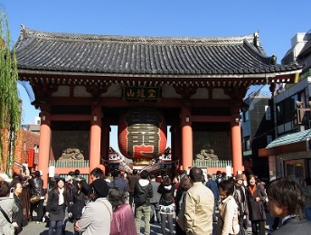
Asakusa Temple is truly a historical haven in modern Tokyo, a gem of the old Edo period (1603-1868). It is the capital’s most famous and oldest Buddhist temple, founded in 628. The famed entrance gate Kaminari-mon (Thunder Gate) with its huge red lantern is a symbol of Asakusa. The 200m-long street of traditional stalls which leads from the Kaminari-mon to the temple, is always enjoyed by visitors.

